Edgewood Bible Church
2021 Missions Conference
September 10-12

Speakers
David Noyes | Lee Downey
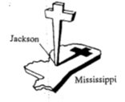  HIWAY BIWAY  Christian Crusade | 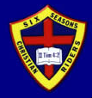
Camie Treptau/Ben Kelm | Clair Longuevan

Meeting Schedule

Friday
7:00pm - David Noyes (ministry spotlight)
- Lee Downey (report/message)

Saturday
7:00am - Men's Breakfast with Clair Longuevan
10:30am - Women’s Ministry Brunch with Mayann Longuevan
7:00pm - Clair Longuevan (ministry spotlight)
- Q & A for all

Sunday
9:30am - Combined Sunday School: David Noyes (chalk talk)
10:30am - Lee Downey (ministry spotlight)
- Clair Longuevan (report/message)
12:00pm - Church Potluck
7:00pm - Village Creek Bible Camp (ministry spotlight & report)

EDGEWOOD BIBLE CHURCH
PO Box 344 - 107 South Washington Street
Edgewood, IA, 52042-0344
563-928-6228
edgewoodbiblechurchonline.org

